5 Why's Worksheet


What Happened?

Why?
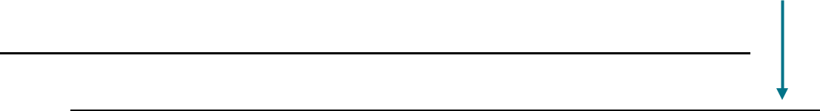

1.

2.

3.

4.

5.

Root Cause

Why?

Why?

Why?


Why?
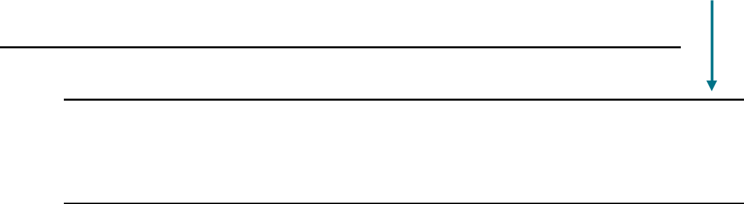

Improvement Actions

